AI Assignment – 2
Que1. Given two jugs- a 4 litre and 3 litre capacity. Neither has any measurable markers on it. There is a pump which can be used to fill the jugs with water. Simulate the procedure in Python to get exactly 2 litre of water into 4-litre jug.
Code :
def get_2l_in_4ljug():
start=[0,0]
a_cap=4
b_cap=3
print(start)
while(start[0]!=2):
if start[0]==0 and start[1]==0:
start[1]=3
elif start[0]==4:
start[0]=0
start[0]=start[1]
start[1]=0
elif start[1]==0:
start[1]=3
elif start[1]==b_cap and start[0]!=a_cap and start[1]!=0:
temp=start[0]
r_cap=a_cap-temp
if r_cap>=start[1]:
start[0]=start[0]+start[1]
start[1]=0
elif r_cap<start[1]:
start[0]=4
start[1]=start[1]-r_cap

print(start)
print("Water Jug Problem starts in which output is [2,] :: ")
get_2l_in_4ljug()
OUTPUT:
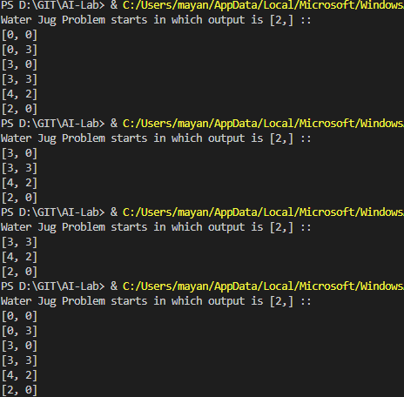
Que2. Given three jugs: 12, 8 and 5 liter capacities. Largest jug is completely filled. Using these 3 jugs, split the water to obtain exactly 6 liter in largest jugs.
Code:
def get_6l_in_12ljug():
start=[12,0,0]
a=12
b=8
c=5
if start[0]+start[1]+start[2]==12:
pass
else:
print("Sum of this problem is not 12")
while(start[0]!=6):
if start[1]==0:
if start[0]<=b:
start[1]=start[0]
start[0]=0
elif start[0]>b:
rem=b-start[1]
start[1]=b
start[0]=start[0]-rem
elif start[2]==0:
if start[1]>=c:
start[2]=c
start[1]=start[1]-c
elif start[1]<c:
start[2]=start[1]
start[1]=0
elif start[2]==c: # c is full
start[0]=start[0]+start[2]
start[2]=0
elif start[2]<c and start[1]==b:
rem=c-start[2]
start[2]=c
start[1]=start[1]-rem
print(start)
print("Water Jug Problem starts in which output is [2, , ] :: ")
get_6l_in_12ljug()
OUTPUT:
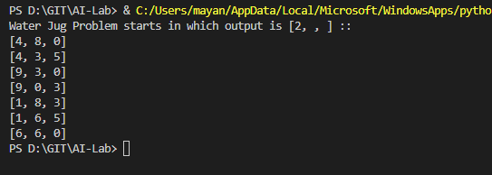
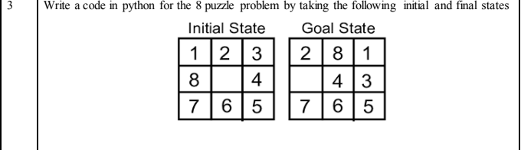
Code:

